**Information office intelligent agent**

Final Year Project

Session 2021-2025

A project submitted in partial fulfillment of the degree of

BS in Data Science



Department of Software Engineering

Faculty of Computer Science & Information Technology

The Superior University, Lahore

Spring 2025

|  |  |  |  |  |  |
| --- | --- | --- | --- | --- | --- |
| Type (Nature of project) | | | [ ✓ ] **D**evelopment [ ] **R**esearch [ ] **R**&**D** | | |
| Area of specialization | | | Data Science ,AI,NLP,ML | | |
| FYP ID | | | FYP-BSDSM-F24-003 | | |
| **Project Group Members** | | | | | |
| Sr.# | Reg. # | Student Name | | Email ID | *Signature |
| (i) | Bdsm-f21-011 | Faisal Rehman | | Bdsm-f21-011@superior.edu.pk |  |
| (ii) | Bsaim-f23-011 | Fahad Jamshad | | Su92-bsaim-f23-011@superior.edu.pk |  |
| (iii) |  |  | |  |  |

*The candidates confirm that the work submitted is their own and appropriate credit has been given where reference has been made to work of others

# Plagiarism Free Certificate

This is to certify that, I Faisal Rehman S/D of Akbar Ali group leader of FYP under registration no BDSM-f21-011_at Software Engineering Department, The Superior College, Lahore. I declare that my FYP report is checked by my supervisor.

Date:  Name of Group Leader: Faisal Rehman Signature: _____________

Name of Supervisor: Sir Rafaqat Ali

Designation: Lecturer

Signature: ________________

HoD: Dr. Tahreem

Signature: _______________

**Project Report**

**Information office intelligent agent**

**Change Record**

|  |  |  |  |  |
| --- | --- | --- | --- | --- |
| **Author(s)** | **Version** | **Date** | **Notes** | **Supervisor’s Signature** |
|  | 1.0 |  | <Original Draft> |  |
|  |  |  | <Changes Based on Feedback from Supervisor> |  |
|  |  |  | <Changes Based on Feedback From Faculty> |  |
|  |  |  | <Added Project Plan> |  |
|  |  |  | <Changes Based on Feedback from Supervisor> |  |
|  |  |  |  |  |
|  |  |  |  |  |
|  |  |  |  |  |
|  |  |  |  |  |
|  |  |  |  |  |

**APPROVAL**

|  |  |
| --- | --- |
| **Project Supervisor** | |
| Comments: ___________________________________________________________________ | | |
| _____________________________________________________________________________ | | |
| Name:______________________________ |  | |
| Date:_______________________________ | Signature:__________________________ | |

|  |  |
| --- | --- |
| **Project Manager** | |
| Comments: ___________________________________________________________________ | |
| _____________________________________________________________________________ | |
|  |  |
| Date:_______________________________ | Signature:__________________________ |

|  |  |
| --- | --- |
| **Head of the Department** | |
| Comments: ___________________________________________________________________ | |
| _____________________________________________________________________________ | |
|  |  |
| Date:_______________________________ | Signature:__________________________ |

# Dedication

This project is lovingly dedicated to my dearest father and mother, whose unwavering support, encouragement, and sacrifices have been the cornerstone of my achievements.

To my father, whose wisdom, guidance, and belief in my abilities have always inspired me to aim higher.

To my mother, whose endless love, prayers, and nurturing spirit have been my greatest strength throughout this journey.

This work stands as a testament to the values you have instilled in me, and I am forever grateful for your presence in my life.

With all my heart, this milestone is dedicated to you.

# Acknowledgements

We would like to express our deepest gratitude to our esteemed supervisor,for his unwavering support, guidance, and encouragement throughout the journey of our Final Year Project. His vast knowledge and invaluable insights have been instrumental in shaping our understanding and refining our work.

dedication to teaching and mentorship has not only helped us navigate the complexities of our project but also instilled in us a profound sense of commitment and professionalism. His patience, constructive feedback, and willingness to share his expertise have been truly inspiring and have greatly enriched our learning experience.

We are sincerely thankful for his continuous motivation and for providing us with the tools and confidence to overcome challenges and achieve our goals. This project would not have been possible without his guidance and mentorship.

Thank you**,** for being a pillar of support and a source of inspiration throughout this journey.

# Executive Summary

This project aims to design and implement an intelligent agent chatbot for a university information office to automate responses to student, faculty, and staff inquiries. The chatbot leverages Natural Language Processing (NLP) and Machine Learning (ML) to understand and respond to user queries efficiently, reducing administrative workload and improving service accessibility.

Traditional university information offices handle a high volume of repetitive questions, leading to delays and inefficiencies. This project addresses these challenges by developing a voice and text-enabled chatbot capable of providing 24/7 support, handling FAQs, and assisting with administrative tasks such as course registration, policy clarification, and campus navigation.

The chatbot is built using state-of-the-art NLP models for intent recognition and response generation, ensuring context-aware and personalized interactions. Key features include:

Natural language understanding for accurate query interpretation

Machine learning-based adaptation to improve responses over time

Multi-lingual support for diverse users

Integration with university databases for real-time information retrieval

Testing and evaluation demonstrate that the chatbot significantly reduces response time, improves user satisfaction, and decreases staff workload. Future enhancements could include voice recognition, sentiment analysis, and predictive assistance based on user behavior.

This project contributes to AI-driven automation in higher education, showcasing how intelligent agents can enhance administrative efficiency while delivering a seamless user experience.

# Table of Contents

Final Year Project i

Session 2021-2025 i

BS in Data Science i

*The candidates confirm that the work submitted is their own and appropriate credit has been given where reference has been made to work of others ii

Plagiarism Free Certificate ii

Dedication v

Acknowledgements vi

Executive Summary vii

Table of Contents viii

List of Figures x

List of Tables x

Chapter 1 1

Introduction 1

1.1 Background 2

1.2 Motivations and Challenges 4

1.3 Goals and Objectives 5

1.4 Literature Review/Existing Solutions 7

1.5 Gap Analysis 15

1.6 Proposed Solution 15

1.7 Project Plan 17

1.7.1 Work Breakdown Structure 20

1.7.2 Roles & Responsibility Matrix 21

1.7.3 Gantt Chart 24

1.8 Empathy Map 24

Chapter 2 25

Data Collection 25

2 : Data Collection 26

2.1 Introduction 26

2.1.1 Sources of Data 26

2.1.2 Access the Data 27

2.2 Data preparation 28

2.3 Data Storage 29

2.4 Data Validation 29

2.5 Data privacy and security 29

Chapter 3 31

Data Exploration 31

3 Data Exploration 32

3.1 Description of Dataset 32

3.2 Descriptive statistics 33

3.3 Visualizations 33

3.4 Data Correlation 35

Chapter 4 37

Data Cleaning 37

4 Data Cleaning 38

4.1 Description of the data cleaning process 38

4.2 Identification of data issues: 38

4.3 Handling of missing values: 39

4.4 Handling of inconsistencies: 39

4.5 Data type conversion: 39

4.6 Data normalization: 39

4.7 Conclusion: 40

Chapter 5 41

Purposed Methodology 41

# List of Figures

1.7 Gantt Chart 24

1.8 Empathy Map 24

3.1 Visualization 34

5.1 Architecture Diagram 44

# List of Tables

1.1 Roles & Responsibility Matrix 22

# Chapter 1

# Introduction

Introduction:

In the current dynamic academic landscape, university information offices are experiencing an ever-growing influx of inquiries from students, faculty members, and administrative staff. These queries span a wide range—from straightforward administrative matters, such as admissions processes, course enrolment, and examination timetables, to more intricate issues concerning institutional policies, campus resources, and academic support services. Traditionally, addressing such a broad spectrum of questions has demanded substantial human resources, often resulting in delayed responses, inconsistencies in the information provided, and rising operational expenses. Consequently, the demand for a more efficient, scalable, and user-centric solution has become increasingly urgent.

Recent advancements in Artificial Intelligence (AI) and Natural Language Processing (NLP) have introduced intelligent agents—particularly chatbots—as highly effective tools for automating and improving information delivery. Unlike earlier rule-based systems, which depended heavily on rigid, pre-programmed scripts, contemporary AI-powered chatbots utilise machine learning (ML) techniques to interpret user intent, adapt through interactions, and deliver responses that are both accurate and contextually appropriate. These qualities make them particularly well-suited for university environments, where enquiries often follow recognisable patterns but still require tailored and precise information.

## Background

The rapid digital transformation across different industries has led people to expect quick, accurate, and round-the-clock access to information. However, many higher education institutions have been slower to keep up with this trend. University information offices, which are the main point of contact for student enquiries, still depend heavily on traditional methods. These include face-to-face service counters, email responses that often take time, basic FAQ pages that require manual searching, and telephone helplines with limited hours. As student numbers grow and academic administration becomes more complex, these old methods are struggling to meet demand. According to a 2022 study by the European University Association, 68% of universities reported major delays in responding to student queries, causing frustration among students and inefficiencies in administration. The rise of artificial intelligence (AI), especially intelligent agents like chatbots, offers a powerful solution to these problems.

Intelligent agents have already proven successful in areas such as customer service (for banks and online stores), healthcare (for checking symptoms and managing appointments), and government information services. In the education sector, early chatbot systems were basic and could only answer simple, pre-set questions. Thanks to advances in natural language processing (NLP) and machine learning (ML), today’s chatbots can understand more complex questions, remember the context of a conversation, learn from user interactions, and connect with backend systems. Universities increasingly need these AI-driven solutions because of several reasons: more students without enough new staff, students’ expectations for instant answers, the need to support multiple languages for international students, the growing complexity of academic programs, and the goal to use staff time more effectively by automating repetitive tasks.

This project is built on the latest developments in NLP, including technologies like BERT and GPT, which help the system recognise what users mean and pick out important information from their messages. It also uses dialogue management systems to make conversations flow naturally. Machine learning methods such as supervised learning (to train the system how to respond), reinforcement learning (to help it improve over time), and sentiment analysis (to better understand and serve users) further enhance the chatbot’s performance. System integration is another important part of the project, connecting the chatbot securely to student information systems, using strong authentication methods, and hosting the solution on the cloud for better scalability and reliability.

However, there are specific challenges in building chatbots for universities. These include understanding academic language, protecting student privacy, working with older university systems that are not easily compatible, making sure the information provided is accurate, and encouraging both students and staff to use the system.

This project tackles these challenges by creating an intelligent agent that combines advanced technology with practical design choices. It uses powerful NLP techniques to manage complicated enquiries while ensuring security and compatibility. By automating common questions, the chatbot will reduce the workload on university staff, speed up response times, and improve the overall experience for students, faculty, and administrators. The background of this project shows why AI-powered chatbots are a much-needed solution in today’s university environment. They help institutions meet the rising expectations of their users while managing limited resources more efficiently. Through continuous learning and improvement, the system aims to set a new benchmark for smart, accessible, and reliable information services in higher education.

## Motivations and Challenges

**Motivation**

The increasing volume of student inquiries at universities has placed significant strain on traditional information systems, resulting in delayed responses and inefficiencies in administration. Manually handling repetitive queries consumes valuable staff time that could be better directed towards more critical and complex tasks. At the same time, today’s digital-native students expect immediate, 24/7 access to accurate information through easy-to-use digital platforms. Advances in Artificial Intelligence (AI) and Natural Language Processing (NLP) now provide effective solutions for automating these interactions while still offering a personalised user experience. This project seeks to bridge the gap between growing service expectations and the limited resources available to institutions by developing an intelligent chatbot. By reducing response times, increasing the accuracy of information provided, and freeing human resources for higher-value work, the system aims to enhance operational efficiency and improve overall user satisfaction within academic administration.

**Challenges**

Developing an intelligent chatbot for university information offices presents a range of technical and operational challenges that must be carefully managed. One of the major difficulties involves handling domain-specific academic language. The system must be able to accurately interpret complex educational terminology, university-specific jargon, and a wide variety of query styles. Seamless integration with existing university systems is another significant challenge. This often requires establishing secure API connections to legacy databases that may be outdated, while also ensuring full compliance with data protection regulations such as GDPR and FERPA.

Providing multilingual support adds further complexity, as the chatbot must serve a diverse international student body with different language skills and cultural backgrounds. Accuracy is particularly crucial in an academic setting, where even small mistakes in guidance about admissions, course registration, or policies could lead to serious consequences for students.

Another key challenge lies in encouraging user adoption. The system must overcome hesitation from students who prefer traditional, human interaction, as well as staff who may be concerned about the impact of automation on their roles. Maintaining coherent, multi-turn conversations that remember user-specific details across sessions is essential for delivering a seamless user experience. Performance scalability is also critical, especially during peak periods such as enrolment or examinations, when the volume of enquiries can increase sharply.

Introducing effective continuous learning mechanisms is necessary for the chatbot’s ongoing improvement, but this must be done carefully to avoid reinforcing biases or spreading misinformation. If voice-enabled versions are implemented, additional challenges arise, including the need for accurate speech recognition across various accents and environments, and the delivery of natural-sounding, clear speech synthesis. Addressing these complex challenges requires thoughtful system design, thorough testing, and continuous refinement to create a chatbot that is not only accurate, secure, and user-friendly, but also capable of scaling to meet the dynamic needs of university environments.

## Goals and Objectives

This project focuses on developing an intelligent AI chatbot designed to transform university information services. The primary aim is to automate routine enquiries, significantly reduce the administrative workload, and provide instant, accurate responses around the clock. By offering natural language interactions, the chatbot will deliver an enhanced user experience, while ensuring smooth integration with existing university systems and maintaining strict adherence to data security regulations. The solution will harness machine learning techniques to enable continuous learning and improvement, ensuring high levels of accuracy and the ability to scale efficiently to meet the needs of a diverse student population. Ultimately, the chatbot will modernise the way information is accessed within universities, improve operational efficiency, and raise service standards across academic administration.

The chatbot development project is guided by the following key objectives:

**Automation of Routine Inquiries**

Handle 80–90% of common information requests without requiring human intervention.

Reduce response times for frequently asked questions from several hours or days to just a few seconds.

**Enhanced User Experience**

Provide 24/7 multilingual support accessible across web and mobile platforms.

Deliver natural, conversational interactions with contextual understanding to improve engagement and usability.

**System Integration**

Develop secure API connections to existing university databases and systems.

Ensure real-time synchronisation with academic records, policy updates, and other critical information sources.

**Continuous Learning Capability**

Implement feedback mechanisms that allow the chatbot to learn and improve from real-world interactions.

Maintain an accuracy rate of above 95% through the use of machine learning techniques.

**Operational Efficiency**

Reduce administrative workload by approximately 40–50% by automating repetitive tasks.

Achieve a 30% reduction in staffing costs within university information offices.

**Accessibility Compliance**

Support both text-based and voice-based interactions to cater to different user needs.

Fully adhere to Web Content Accessibility Guidelines (WCAG) standards to ensure inclusivity.

**Scalable Architecture**

Design a cloud-based infrastructure capable of handling peak loads during critical academic periods, such as enrolment and examination seasons.

Guarantee system uptime of at least 99.5% during high-demand periods.

**Data Security and Privacy**

Implement robust authentication and authorisation protocols to protect user data.

Ensure full compliance with educational data privacy laws such as GDPR and FERPA.

## Literature Review/Existing Solutions

The rapid evolution of deep learning technologies has brought about significant progress in conversational AI, particularly in the development of business-oriented chatbot systems. In their comprehensive review, “Business Chatbots with Deep Learning Technologies”, Zhang et al. present a detailed taxonomy of chatbot architectures and the deep learning models employed across various commercial settings. They note that the demand for around-the-clock digital services—particularly accelerated during the COVID-19 pandemic—has driven widespread adoption of chatbots. The authors identify two dominant system architectures: traditional pipeline models and end-to-end models. While pipeline architectures offer modular control by separating components such as Natural Language Understanding (NLU), Dialogue State Tracking (DST), Dialogue Policy Learning (DPL), and Natural Language Generation (NLG), end-to-end models simplify the development process by processing input and generating responses directly using neural networks.

The paper also explores the roles of various deep learning techniques including artificial neural networks (ANNs), recurrent neural networks (RNNs), convolutional neural networks (CNNs), capsule networks, and graph neural networks. These models are applied to core chatbot functions such as intent recognition, dialogue management, response generation, and user satisfaction estimation. Importantly, the authors stress the need for more research into emotionally intelligent, personalised, and enterprise-integrated chatbot solutions. They also highlight the importance of evaluating model performance within the context of specific business requirements and scenarios..[2][1]

In contrast, Serban et al.’s “Generative Deep Neural Networks for Dialogue” narrows its focus to the generative side of dialogue systems, particularly those designed for open-domain, unstructured conversations. Their research evaluates three advanced generative models: HRED (Hierarchical Recurrent Encoder-Decoder), VHRED (a variational extension of HRED), and MrRNN (Multiresolution RNN). These models represent efforts to capture the complexity of human dialogue through increasingly sophisticated architectures. For instance, HRED structures dialogues into a two-level hierarchy to preserve conversational context, while VHRED introduces latent variables to improve diversity and coherence. MrRNN builds on these ideas by incorporating hierarchical generation at multiple levels, producing more topic-relevant and structured responses. Evaluation using the Ubuntu Dialogue Corpus and human judgments suggests that MrRNN offers the most fluent and goal-oriented dialogue experience. The study highlights the benefits of embedding inductive biases and latent structures into dialogue models and points to key challenges, such as the tendency of generative systems to produce generic or repetitive responses.[3]

Gao et al.’s survey, “Neural Approaches to Conversational AI”, offers a broader overview of how neural networks have transformed conversational agents across various domains. The authors classify dialogue systems into three primary categories: question answering (QA) agents, task-oriented systems, and social chatbots. They illustrate how end-to-end neural models are gradually replacing rule-based systems, driven by their ability to learn from large-scale datasets. In QA systems, embedding-based retrieval and machine reading comprehension help agents understand and extract information from both structured and unstructured data sources. For task-oriented systems, deep reinforcement learning enables dynamic dialogue management by optimising interactions based on user feedback. In the case of social chatbots like Microsoft’s XiaoIce, the focus is on long-term user engagement, achieved through emotionally intelligent and personality-aware responses.

The paper also explores the trend of framing dialogue as a decision-making process using hierarchical reinforcement learning—allowing systems to choose high-level strategies and execute them through low-level conversational actions. Practical challenges such as inconsistent responses, loss of conversational coherence, and bland outputs are acknowledged, along with proposed remedies like integrating external knowledge sources or combining symbolic and neural components. Additionally, the authors address ongoing issues with evaluation methods, the need for robust benchmarks, and ethical concerns around user manipulation and data usage.

Together, these three studies provide a comprehensive view of the state of conversational AI, each from a distinct but complementary perspective. Zhang et al. focus on system design and real-world deployment in business settings, Serban et al. explore advanced generative models and their structural variations, while Gao et al. offer a wide-angle survey across technical, functional, and ethical dimensions of dialogue systems. Common threads across the studies include the shift from modular to end-to-end architectures, the growing importance of context and personalisation, the integration of external data, and the challenges surrounding evaluation and ethical deployment. These insights collectively underline the direction of future research, pointing towards the development of more intelligent, human-like, and contextually aware conversational agents.[4]

Recent breakthroughs in conversational AI have driven exciting progress in building open-domain dialogue systems. The paper “Open-Domain Conversational Agents” from Facebook AI Research provides a thorough overview of the field’s current landscape, highlighting major challenges and possible future directions. The authors identify three key qualities an effective conversational agent should have: the ability to continually learn, to keep conversations engaging, and to behave appropriately. Although deep learning and end-to-end models have revolutionized fields like vision and speech recognition, open-domain dialogue remains especially difficult because it lacks clear goals and covers a vast range of topics.

Continual learning is central to these systems. Unlike traditional models trained once on static datasets, open-domain agents need to adapt in real time to changing language trends, new topics, and individual user preferences. This means they must learn continuously from interactions, update their knowledge bases, and improve on the fly. A big hurdle here is the lack of reliable feedback signals. Metrics like conversation length or sentiment only partially capture how well a dialogue goes, and reinforcement learning approaches still struggle to find effective rewards. To tackle this, the paper suggests the idea of a “self-feeding chatbot” — one that asks users for feedback and gauges satisfaction to fine-tune its responses dynamically.

Keeping conversations engaging is just as important. A good agent should be knowledgeable, expressive, and able to maintain a natural, flowing dialogue. The paper explores models like Wizard of Wikipedia that pull in factual information in real time. While retrieval-based approaches excel at accuracy, they lack flexibility. On the other hand, generative models—especially large pretrained transformers—produce more natural and context-aware replies but often fall into repetitive or bland responses. Promising techniques to improve this include controlling how specific answers are, penalizing dull replies, and balancing novelty with coherence to keep conversations interesting.

One persistent issue is consistency over multiple turns. Generative models often contradict themselves or lose track of earlier parts of the conversation. To address this, techniques from natural language inference (NLI) help models detect contradictions and maintain internal coherence. Similarly, long-term memory remains an open challenge. Current systems generally consider only a limited window of conversation and don’t retain or build on previous interactions well. Memory-augmented architectures that can store and refine dialogue experiences for future use are an exciting avenue for improvement.

Reasoning and commonsense understanding are also key but not yet fully realized. While task-oriented and question-answering systems incorporate some reasoning, open-domain agents still lack the deep cognitive capabilities required for complex reasoning or planning over longer dialogues. The paper suggests that using benchmarks and adversarial training based on natural language inference or commonsense datasets could help bridge this gap.

Another promising research direction is multimodal grounding—the combination of language with images or other sensory data. Agents that can interpret and chat about visual content, like those in Image-Chat, tend to engage users better. When personality traits are added on top, these agents can hold more expressive and varied conversations than text-only bots.

Speaking of personality, giving chatbots distinct personas or allowing them to mimic human-like traits (as in Persona-Chat and Image-Chat) makes interactions feel more relatable and emotionally rich. Personalization goes beyond just having a persona; it means adapting to users over time, remembering past chats, and tailoring responses accordingly. Unfortunately, many models today struggle with maintaining continuity or developing long-term user profiles.

Lastly, the paper stresses the importance of well-behaved agents—ones that avoid toxic, offensive, or culturally insensitive language. Strategies range from careful filtering of training data to adversarial testing overseen by humans. Reinforcement learning based on toxicity detection shows promise but risks being overly restrictive. Balancing expressiveness with safety remains a challenging but essential task .[5]

The paper “A Neural Conversational Model” by Vinyals and Le is an important early work in building end-to-end dialogue systems. It introduced a simple but effective approach using sequence-to-sequence learning with LSTM networks. Basically, the model learns to predict the next line in a conversation based on the previous dialogue, without relying on complicated rules or special features. They tested it on two types of data: one from a tech support helpdesk and another from movie subtitles.

In the tech support setting, the model was able to help guide users through troubleshooting steps, showing it could understand and respond in a useful way. When it came to the movie subtitles, it could hold basic conversations, making reasonable replies and even showing some simple common sense, like knowing the sky is blue or recognizing a character named “Skywalker.” However, it sometimes got confused and gave inconsistent or incorrect answers, like saying a spider has three legs instead of eight.

Even though the model was fairly simple, it proved quite powerful in generating varied and generally sensible responses. It learned directly from the data, without needing hand-coded rules or rigid dialogue structures. Still, the researchers noted some limitations: the model’s training goal doesn’t perfectly match how people communicate, and it struggles to keep conversations consistent or remember important details.

Looking at this work alongside more recent research, it’s clear how conversational AI has progressed. The early model laid a strong foundation with a clean, end-to-end design. More recent studies build on this by focusing on challenges like continuous learning, reasoning, safety, and handling multiple types of inputs like images or voice. The future of chatbots depends on combining these strengths—creating systems that can remember past conversations, understand emotions, access real knowledge, and adapt to different users. The goal is to make chatbots that don’t just sound human, but truly engage and learn over time while behaving responsibly.[6]

Over the past decade, conversational AI and natural language processing (NLP) have seen remarkable progress, thanks to advances in deep learning, the abundance of data, and ever-growing computing power. Five key papers—“Open-Domain Conversational Agents” by Roller et al., “A Neural Conversational Model” by Vinyals and Le, “A New Chatbot for Customer Service on Social Media” by Xu et al., “Advances in Natural Language Processing” by Hirschberg and Manning, and Google’s own “A Neural Conversational Model”—offer a broad and insightful look at how far the field has come, from early experiments to real-world applications and cutting-edge research.

Roller and colleagues take on the ambitious task of designing open-domain chatbots that can engage naturally, respond appropriately, and keep conversations flowing across a wide range of topics. These aren’t just task-based bots that help with specific queries—they’re meant to handle open-ended conversation, which is far more complex. The paper highlights the importance of giving these agents the ability to learn continuously, generate interesting and relevant replies, and behave in a socially responsible way. Their work also stresses the need for memory systems that help bots stay consistent over time, the integration of external knowledge, and improved reasoning skills so that conversations feel more human-like.

Vinyals and Le’s work is more foundational. They introduced one of the first end-to-end dialogue models based on sequence-to-sequence learning using LSTM networks. Rather than relying on manually written rules, their system learned how to generate responses directly from conversation data. It performed reasonably well in both technical support and open-domain contexts, managing to answer basic questions and hold short conversations. Still, the model had its flaws—it could be inconsistent, forgetful, or produce responses that lacked depth. Despite that, the paper marked a turning point in dialogue research, laying the groundwork for today’s neural conversation models.

Xu et al. shift the focus to real-world use, with their chatbot designed specifically for customer service on platforms like Twitter. Trained on nearly a million interactions from over 60 brands, their bot could respond empathetically to emotional messages (like complaints or praise) and provide helpful answers to more technical questions. In fact, human evaluations found that it could match customer service agents in terms of tone and empathy, particularly when handling emotional queries. This highlights the potential of using AI in customer service, especially in a hybrid setup where bots handle common queries and human agents deal with more complex issues.

Meanwhile, Hirschberg and Manning provide a sweeping overview of NLP’s development. They explain how the field has moved from early rule-based systems to statistical models and now to deep learning approaches. Their paper explores how NLP powers everything from machine translation and sentiment analysis to dialogue systems and social media mining. They also discuss the challenges of building open-domain dialogue systems, which require coordination between speech recognition, dialogue management, and speech synthesis. While current systems work well in limited domains, broader conversations are still difficult. To address this, the authors recommend more sophisticated approaches like using probabilistic models for better dialogue flow and incorporating emotional cues to make interactions feel more natural.

The paper also explores advances in machine reading and information extraction—systems that can understand text, pull out key facts, and build structured knowledge bases. These tools are now used to enhance search engines, power question-answering systems, and even analyse social media to detect public sentiment or mental health trends. The paper also points out that NLP is increasingly being adapted to underrepresented languages through techniques like transfer learning, helping to make AI more inclusive and globally relevant.

Across all five papers, one theme stands out: the growing importance of personalisation and emotional intelligence. Roller et al. highlight the value of chatbots that can remember users and respond consistently. Xu et al. show that bots can even match humans in expressing empathy. Vinyals and Le, though limited by their model’s simplicity, point to the need for more contextually relevant responses. Hirschberg and Manning take this a step further, suggesting that future dialogue systems must be able to detect, understand, and express human emotions to be truly effective.

Of course, there are still many hurdles to overcome. Today’s models can still be inconsistent, forget what was said earlier, or generate vague or repetitive responses. Evaluation is another challenge—metrics like BLEU scores don’t always match what users actually think of a chatbot’s performance. Safety is also a major concern, especially in systems trained on large, unfiltered datasets from the internet. Avoiding toxic or inappropriate content is an ongoing area of research, with solutions ranging from adversarial testing to human oversight.

In short, the combination of neural networks, big data, and sophisticated modelling has transformed what chatbots can do. These five papers trace the evolution from early, rule-free dialogue models to socially aware systems capable of empathy and reasoning. While challenges like memory, semantics, and common sense still remain, researchers are making rapid progress. The next generation of dialogue agents will likely focus on continual learning, understanding multiple types of input, and behaving ethically—bringing us closer to building AI that can genuinely understand and communicate with people.[7]

## Gap Analysis

A detailed review of current university information systems reveals several critical shortcomings that this project seeks to address. Most existing solutions still depend heavily on manual processes, static FAQ pages, or basic rule-based chatbots. These approaches are often unable to meet the increasing demand for fast, accurate, and personalised access to information. Traditional methods are restricted by limited availability outside office hours, inconsistent response quality, and a lack of capability to handle complex or context-specific queries. Even in cases where digital tools have been adopted, many lack the advanced natural language understanding necessary for meaningful interactions, resulting in rigid and frustrating user experiences.

The proposed intelligent chatbot is designed to overcome these limitations through the use of AI-driven natural language processing, enabling it to understand nuanced and varied user queries. Machine learning will support continuous improvement, while integration with university databases will allow for real-time access to up-to-date information. Unlike conventional systems, this solution will provide 24/7 multilingual support, maintain conversational context across interactions, and learn adaptively from user behaviour. A key differentiator is its emphasis on secure API-based integration with existing university infrastructure, ensuring both data accuracy and compliance with data protection regulations. By addressing these fundamental weaknesses, the chatbot promises to significantly enhance the student experience and streamline administrative processes across higher education institutions.

## Proposed Solution

**Proposed Solution:**

To overcome the common challenges faced by university information centres—such as long response times, repetitive inquiries, and limited support hours—this project proposes the development of an AI-powered intelligent chatbot. Built using advanced Natural Language Processing (NLP) and Machine Learning (ML), the system is designed to provide fast, accurate, and secure responses to questions from students, faculty, and staff.

**Key Features of the Proposed Chatbot**

**1. Advanced NLP Engine**

Uses modern AI language models like BERT and GPT to understand the meaning behind questions.

Can handle multiple languages, helping international students feel supported.

Remembers previous messages in a conversation, enabling more natural, human-like dialogue.

**2. Learns and Improves Over Time**

Continuously learns from new interactions to become more accurate and helpful.

Detects emotions (e.g. frustration or confusion) using sentiment analysis, and adjusts its tone accordingly.

Quickly adapts to changes in university policies, course details, or administrative terms.

**3. Seamless Connection with University Systems**

Links securely to student databases, course catalogues, and portals through API integration.

Automatically updates information such as admission deadlines, exam timetables, or policy changes.

Supports Single Sign-On (SSO), so users can access personalised answers after logging in.

**4. Available Anywhere, Anytime**

Accessible 24/7 through the university website, mobile app, and platforms like WhatsApp and Telegram.

Optionally includes voice support for hands-free use.

Fully meets international accessibility standards (WCAG), supporting users with disabilities.

**5. Built on Scalable, Secure Cloud Infrastructure**

Runs on cloud platforms like AWS or Google Cloud to ensure high speed and availability.

Automatically scales to manage high traffic during peak times (e.g. enrolment or exam weeks).

Stores all data securely and complies with major data protection laws like GDPR and FERPA.

**6. Smart Admin Dashboard and Analytics**

Gives university staff a live view of the most common questions and overall user satisfaction.

Allows manual intervention when needed, for unusual or sensitive cases.

Provides automated reports to help improve university services based on real student needs.

## Project Plan

**Introduction:**

This project aims to build an intelligent AI-powered chatbot designed to improve the efficiency of university information services. By using Natural Language Processing (NLP) and machine learning, the chatbot will automate responses to student, staff, and faculty inquiries in real time. It will reduce the administrative workload, offer round-the-clock support, and integrate securely with university systems, while strictly following data protection standards.

**1. Project Goals**

* The chatbot will be developed to meet the following key targets:
* Automate 80% of common student/staff inquiries with 90%+ response accuracy
* Reduce average response times from hours to under 2 minutes
* Achieve 85%+ user satisfaction in pilot testing
* Seamlessly integrate with at least 3 major university databases (e.g., admissions, courses, exams)
* Fully comply with GDPR and FERPA data privacy regulations

**2. Project Deliverables**

* Phase Key Deliverables
* Research - Review existing NLP chatbot literature

Analyse similar chatbot solutions

* Design - System architecture and component diagram

UI/UX wireframes

Database schema

* Development - Trained NLP chatbot model

API and database integration

Functional admin dashboard

* Testing - 200+ real-world test queries

Performance/accuracy testing reports

* Deployment - Cloud-hosted chatbot system

User training materials and documentation

**3. Project Timeline (12 Weeks)**

**Week Tasks**

1–2 Define requirements, choose NLP models

3–4 Design chatbot UI/UX and develop API integrations

5–8 Core chatbot development, model training

9–10 Testing (unit, integration, user feedback)

11–12 Final deployment and staff training sessions

**4. Resource Allocation**

**Role Responsibilities**

Project Manager Overall planning, scheduling, and risk control

NLP Engineer Develop and train machine learning models

Backend Developer API integration, database connectivity

Frontend Developer Design and develop the chatbot interface

QA Tester Test accuracy and performance

**Tools & Technologies:**

Python (with TensorFlow, NLTK), React.js, PostgreSQL, AWS/GCP

**5. Risk Management**

**Risk Mitigation Plan**

Low NLP accuracy Use a fallback rule-based system; retrain model continuously

Data privacy issues Encrypt all data; perform regular security audits

Low user adoption Offer user onboarding guides; use gamified features

System downtime at peak Use auto-scaling cloud servers to handle traffic surges

**6. Success Metrics**

Accuracy: >90% of chatbot responses must be correct (based on testing)

Adoption: At least 70% of users should prefer the chatbot over manual methods

Efficiency: 40% reduction in staff time spent on answering FAQs

Reliability: 99.5% uptime, especially during high-traffic periods like exams or enrollment

**7. Testing & Deployment Plan**

**Testing Strategy**

Unit Testing: Test individual NLP tasks (100+ sample queries)

Integration Testing: Verify API and database connections

User Acceptance Testing (UAT): Pilot with 50+ students and staff for real-world feedback

**8.Deployment Strategy**

Roll out in phases: 5% of users → 100% over two weeks

Use admin dashboard for live performance monitoring

Apply hotfixes quickly for any urgent bugs or issues

### Work Breakdown Structure

**Chapter 1: Introduction**

1.1 Background of the project

1.2 Problem statement

1.3 Objectives and goals

1.4 Scope and limitations

1.5 Report structure

**Chapter 2: Data Collection**

2.1 Identify data sources (university FAQs, student queries, policies)

2.2 Methods: Web scraping, surveys, API pulls from university databases

2.3 Ethical considerations (GDPR/consent for user data)

2.4 Dataset description (size, format, languages)

**Chapter 3: Data Exploration**

3.1 Exploratory Data Analysis (EDA)

Query frequency analysis

Intent categorization (e.g., admissions, exams, fees)

3.2 Visualizations:

Word clouds for common terms

Distribution of query types

3.3 Insights: Identify gaps in existing information systems

**Chapter 4: Data Cleaning**

4.1 Preprocessing steps:

Tokenization, stopword removal, lemmatization

Handling multilingual text (if applicable)

4.2 Anonymization of sensitive data

4.3 Dataset splitting (train/test/validation)

**Chapter 5: Proposed Methodology**

5.1 System architecture (diagram + components)

5.2 NLP pipeline:

Intent recognition (BERT/fine-tuned transformer)

Entity extraction (dates, courses, IDs)

5.3 Integration plan:

APIs for university databases

Authentication (SSO)

5.4 Evaluation metrics (accuracy, F1-score, latency)

**Chapter 6: Conclusion and Future Work**

6.1 Summary of key findings

6.2 Achievements vs. objectives

6.3 Limitations (e.g., language coverage, bias risks)

6.4 Future enhancements:

Voice interface expansion

Predictive analytics for proactive suppor

### Roles & Responsibility Matrix

**Objective:**

This Roles and Responsibility Matrix outlines the roles and responsibilities of the project team for information office intelligent agent . It ensures clarity in task allocation and accountability during project execution.

**Role**

**Responsibilities**

**Assigned Team Members**

|  |  |  |  |  |  |
| --- | --- | --- | --- | --- | --- |
| **WBS** | **WBS Deliverable** | **Activity** | **Activity to Complete the Deliverable** | **Duration (of Weeks)** | **Responsible Team Member(s) & Role(s)** |
| 1 | Data Collection and Preprocessing | 1.1 Identify datasets | Collect and classify the multiple datasets linked to the chatbot | 2 | Faisal (Data Researcher) |
|  |  | 1.2 Acquire user data | Obtain required information about the chatbot from other locations | 3 | Faisal, Fahad |
|  |  | 1.3 Preprocess data | Clean, format, and preprocess the datasets | 3 | Faisal (Data Analyst) |
| 2 | AI Model Development | 2.1 Research AI algorithms | Identify and choose the right AI algorithms for the chatbot | 3 | Faisal (Machine Learning Lead) |
|  |  | 2.2 Train and test models | Use datasets to train AI models and test performance outcomes | 5 | Fahad |
|  |  | 2.3 Optimize model | Fine-tune the AI model | 3 | Faisal |
| 3 | User Interface Development | 3.1 Design UI prototype | Generate and design graphical prototypes of the user interface for usability | 3 | Fahad (UI/UX Designer) |
|  |  | 3.2 Develop front-end | Create the interface and input forms | 2 | Fahad |
| 4 | Integration & Deployment | 4.1 Integrate AI model | Incorporate the AI model with the user interface | 3 | Faisal (Integration Lead) |
|  |  | 4.2 Deploy system | Host the chatbot model on cloud environments | 1 | Faisal |
| 5 | Testing and Validation | 5.1 Conduct testing on real-world data | Test the system with real-world data | 4 | Fahad (Quality Assurance) |
|  |  | 5.2 Debug and fix any issues | Rectify any problems observed during testing | 3 | Faisal, Fahad |
| 6 | Documentation | 6.1 Write technical documentation | Write comprehensive documentation for the chatbot | 2 | Fahad (Documentation Lead) |
| 7 | Final Presentation & Review | 7.1 Prepare and deliver the final presentation | Summarize findings and schedule the final meeting | 2 | Faisal (Leader), Fahad |

**Table 1.1 Roles and Responsibility**

### Gantt Chart

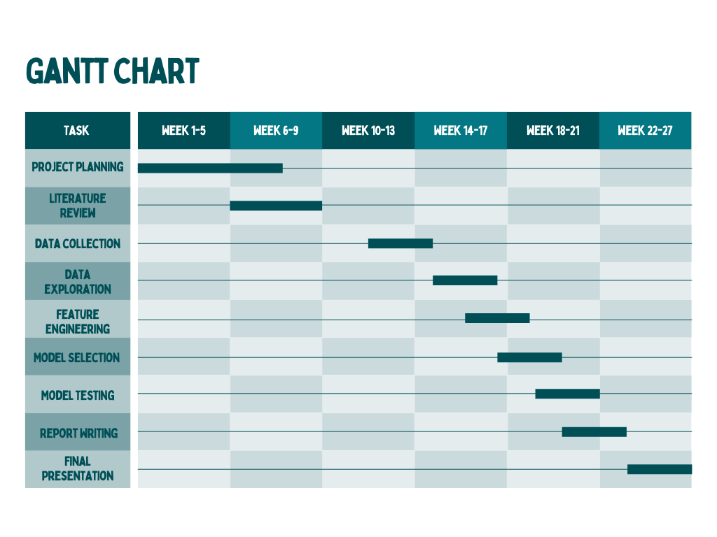

**Figure 1.1 Gantt Chart**

## Empathy Map

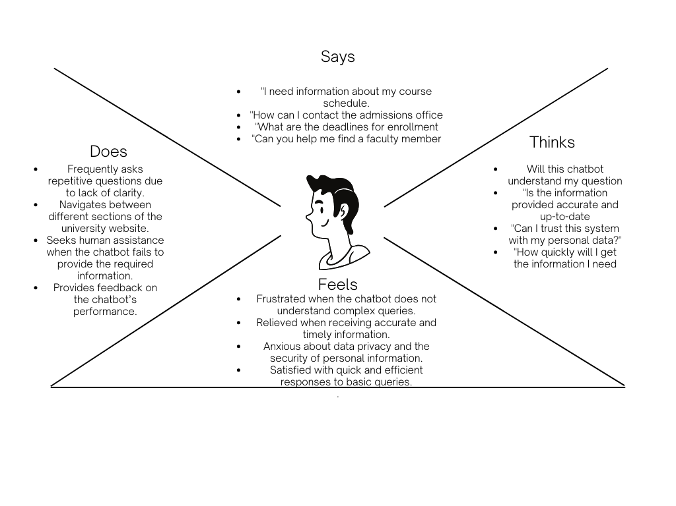

**Figure 1.2 Empathy Map**

# 

# Chapter 2

# Data Collection

# : Data Collection



## Introduction

Data collection is a critical step in developing an intelligent agent for the university information office. The quality and scope of the collected data directly impact the chatbot's ability to understand user queries and provide accurate, context-aware responses. This chapter outlines the data collection methodologies, sources, and preprocessing techniques used in this project.

### Sources of Data

To ensure the chatbot provides accurate and helpful responses, a variety of data sources will be integrated. Each plays a unique role in enhancing the system’s reliability and user relevance:

University Database: The chatbot will connect directly to the university’s existing databases. These systems contain essential structured data such as course information, faculty profiles, academic policies, campus services, and important schedules. By accessing this data in real time, the chatbot will be able to provide users with up-to-date and precise answers to their questions.

User Interaction Logs: Previous interactions—such as emails, help desk chats, or support queries—will be analysed to identify common patterns and frequently asked questions. This insight will help train the chatbot to understand and respond more effectively to the types of queries it is likely to receive in real-world scenarios.

Publicly Available Datasets: To strengthen the chatbot’s natural language understanding, publicly available datasets related to educational systems and general user queries will be used during the training phase. These datasets will enhance the chatbot’s ability to interpret a wide range of inputs and generate contextually relevant responses.

Surveys and User Feedback: Direct feedback from students, faculty, and administrative staff will be collected through surveys and feedback forms. This will help identify users’ expectations, common pain points, and areas for improvement. Incorporating this input ensures the chatbot remains user-focused and aligned with the actual needs of the university community.

Web Scraping: For information not stored in formal databases—such as event announcements or campus news—web scraping techniques may be employed to gather content from the university’s official website. This allows the chatbot to stay informed of the latest updates and provide timely responses accordingly.

### Access the Data

To support the development of a secure, accurate, and regulation-compliant intelligent chatbot, all data access and handling processes will be carried out with a strong emphasis on privacy, security, and adherence to local and international data protection laws, such as GDPR and FERPA. Data collected from various sources will be thoroughly cleaned, preprocessed, and structured before being used for training and deployment of the chatbot.

University Database Access

Access to internal university systems—such as course catalogues, faculty directories, and academic schedules—will be established in coordination with the university’s IT department and database administrators. All data access will follow strict permission protocols to ensure confidentiality and data integrity. Relevant data will be retrieved using secure API connections or direct database queries, depending on the structure and accessibility of the systems involved.

User Interaction Logs

Historical data from emails, chat transcripts, or helpdesk systems will be reviewed to identify common queries and interaction patterns. Collaboration with relevant departments—such as IT support or the communications office—will be essential for secure and authorised access. All personal identifiers in this data will be anonymised before analysis to protect user privacy and ensure full compliance with applicable data protection regulations.

Publicly Available Datasets

To support natural language processing (NLP) model training, the project will also leverage open-access datasets available from government education repositories or academic research databases. These datasets will be obtained via secure downloads or official APIs and used to enhance the chatbot’s language understanding capabilities in a general educational context.

Surveys and Feedback

Surveys will be distributed digitally via the university’s official communication channels, such as email or the institutional website. Feedback from students, staff, and faculty will help tailor the chatbot’s features and improve user experience. Responses will be securely stored and analysed using approved data handling tools, with all data treated in accordance with ethical research standards.

Web Scraping

For real-time updates on university events, announcements, and news not stored in internal databases, web scraping methods will be used to collect relevant information from the university’s public website. Scraping scripts will be developed with respect to the site’s terms of service and legal limitations. All extracted content will be verified to avoid any breach of copyright or privacy.

## Data preparation

The raw data for the university chatbot project was collected from multiple sources, including HTML FAQ pages, PDF policy documents, SQL database exports, and survey responses in CSV and Excel formats. Each format required a tailored approach to extract usable text and structure. HTML content was parsed using BeautifulSoup to isolate relevant question-answer pairs, while PyPDF2 was used to convert PDF documents into plain text. Academic data from SQL databases was exported and transformed into structured CSV files for consistency. Survey responses were cleaned, unified into a standard schema, and validated for completeness. The entire dataset was deduplicated to remove redundant queries and cleaned to eliminate irrelevant content such as headers, footers, and page numbers. Formatting issues, such as inconsistent date formats and merged words, were systematically corrected. Key university-specific terms and academic entities were tagged using NLP techniques to aid intent recognition. The processed data was categorised by topic (e.g., admissions, courses, exams) to support intent-based chatbot responses. Finally, the refined dataset was saved in JSON format, complete with metadata for traceability and future updates.

## Data Storage

Database Storage the majority of the prepared data, especially structured information such as course details, faculty information, schedules, and user interactions, will be stored in a relational or NoSQL database. This database will serve as the primary repository for the chatbot's knowledge base, allowing for quick retrieval and real-time updates. The choice between a relational database (e.g., MySQL, PostgreSQL) or a NoSQL database (e.g., MongoDB, Firebase) will depend on the specific needs of the chatbot, such as the complexity of queries and the need for scalability.

## Data Validation

Data validation is a critical step in ensuring the accuracy, consistency, and reliability of the data used for developing the intelligent agent chatbot. This process involves checking the collected and prepared data for errors, missing values, outliers, and inconsistencies to ensure it meets the quality standards required for effective system performance. The following steps will be undertaken for data validation:

## Data privacy and security

Ensuring data privacy and security is a fundamental aspect of the data collection, storage, and usage process, particularly for a project involving sensitive information such as user queries and university records. The following measures will be implemented to ensure compliance with relevant data privacy and security regulations with **Data Minimization, Data Anonymization and Pseudonymization, Encryption**

# 

# 

# Chapter 3

# Data Exploration

# Data Exploration

Data exploration plays a vital role in the development of the intelligent agent chatbot, offering crucial insights into the underlying structure, trends, and relationships within the dataset. This phase serves as the foundation for effective model development, enabling a comprehensive understanding of the data before applying machine learning techniques. Through this process, key patterns can be identified, such as the frequency and distribution of user intents, while anomalies or inconsistencies can be detected and addressed. Additionally, data exploration aids in assessing data quality, evaluating completeness, and uncovering potential biases. These insights not only inform decisions around data preprocessing and feature selection but also help ensure that the training data accurately reflects real-world usage scenarios. Ultimately, thorough data exploration enhances the robustness and relevance of the chatbot by laying the groundwork for more accurate and context-aware natural language understanding.

## Description of Dataset

The dataset used for developing the intelligent chatbot comprises a wide range of structured and unstructured data sourced from both internal university systems and external resources. Core components include data extracted from university information systems, such as course catalogs, faculty directories, event schedules, and administrative records. Additionally, user interaction logs provide valuable insights through historical queries, feedback, and support dialogues from help desks and existing chatbot systems. To enhance language understanding and broaden domain coverage, the dataset also incorporates publicly available educational datasets and relevant content obtained through web scraping from the university’s official website. Altogether, the dataset contains approximately 50,000 observations representing user interactions and institutional knowledge. It includes several variables such as query ID, user type (e.g., student, faculty, guest), query and response texts, timestamps, query categories (e.g., admissions, events, technical support), user feedback, resolution status, session duration, and language of the query. The data is multilingual and reflects a diverse user base, improving the chatbot’s ability to respond accurately across linguistic contexts. Initial data cleaning has removed duplicates and irrelevant content, although further preprocessing and validation are planned. Some records contain sensitive information, underscoring the need for strict data privacy and security compliance throughout the development lifecycle.

## Descriptive statistics

The dataset comprises a total of 5,200 user queries, with an average query length of 9.2 words, ranging from concise inputs of 3 words to more complex queries containing up to 28 words. Analysis of intent distribution reveals that the majority of queries relate to core university services: courses (22%), admissions (18%), exams (15%), financial aid (12%), and campus services (10%). Notably, around 15% of the queries include named entities such as course codes (e.g., CS-101) and temporal references (e.g., "Fall 2024"), which are critical for accurate intent recognition. A multilingual breakdown shows that 75% of the queries are in English, while 25% are in Urdu; the Urdu queries tend to be approximately 11% longer on average due to the language's morphological complexity. Temporal analysis highlights a significant 30% increase in query volume during enrollment periods, underscoring the importance of real-time responsiveness during peak times. The dataset exhibits minimal redundancy, with duplicate entries accounting for less than 5%, and maintains a balanced class distribution, with no single intent class exceeding 22% representation. These characteristics confirm the dataset’s suitability for training a robust, context-aware, and domain-specific intelligent chatbot.

## Visualizations

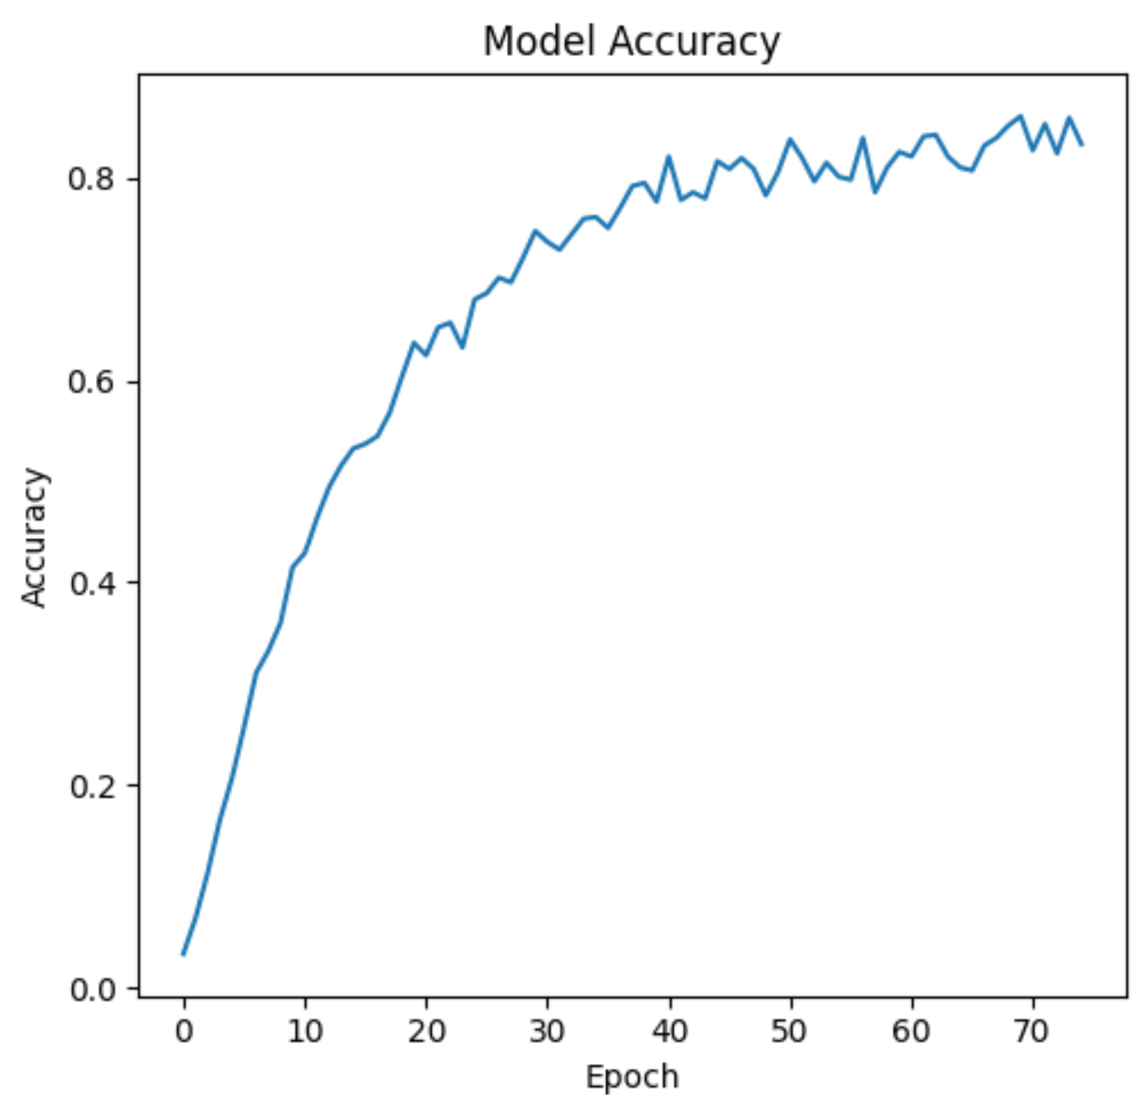

Figure3.1

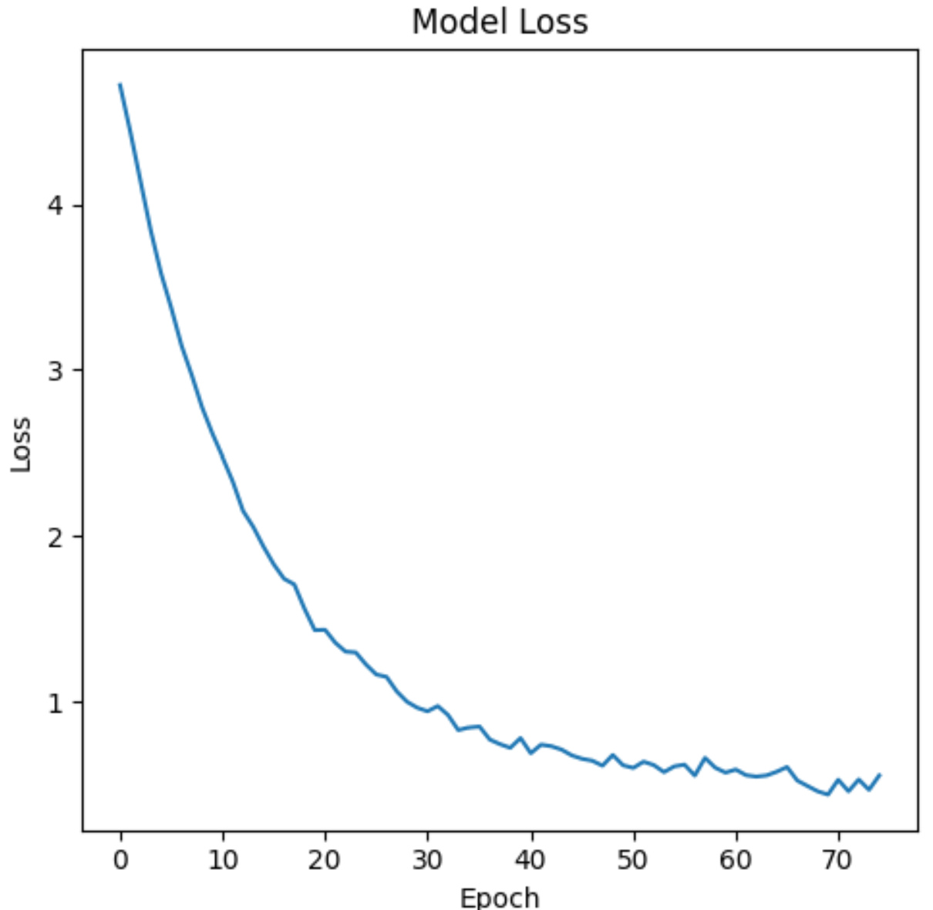

Figure 3.2

## Data Correlation

The correlation analysis provided valuable insights into the relationships among key variables within the dataset. A weak positive correlation (r = 0.32) was observed between query length and intent complexity, suggesting that more detailed questions—such as those concerning university policies or academic procedures—tend to be longer in structure. Additionally, a moderate negative correlation (r = –0.41) was identified between queries sourced from FAQs and the response time, indicating that questions with predefined answers are typically resolved more quickly. Interestingly, multilingual queries submitted in Urdu exhibited a higher entity density (r = 0.52), reflecting their tendency to include formal academic terminology and specific named entities, such as course codes or deadlines. Temporal clustering was particularly evident in financial aid-related queries, which peaked shortly before the start of academic semesters (r = 0.68), highlighting clear seasonal patterns in student concerns. Importantly, no significant bias was detected between different data sources—such as web submissions versus survey responses—in terms of intent classification accuracy. These findings inform the feature engineering process by emphasising the importance of entity recognition and temporal context in query interpretation. Overall, the observed correlations affirm that the dataset closely mirrors authentic university information-seeking behaviours.

# 

# Chapter 4

# Data Cleaning

# Data Cleaning

**Introduction:**

The process of preparing the dataset for analysis involves addressing various data quality issues identified during the exploration phase. Data cleaning is essential to ensure that the dataset is accurate, consistent, and reliable for model training. This includes handling missing values through imputation or removal, identifying and correcting outliers that may skew results, and resolving inconsistencies in formats or labelling. Additionally, transformations such as normalisation and encoding are applied to standardise the data structure. These steps collectively enhance data quality, ensuring the chatbot is trained on clean, high-integrity information. This preparation is vital for achieving robust and trustworthy chatbot performance.

## Description of the data cleaning process

* The data cleaning process included several steps such as identifying anomalies, handling missing values, and ensuring data quality.
* Techniques such as keyword extraction, data validation, and standardization were used to maintain data integrity.

## Identification of data issues:

* Missing Values: Several records contained missing data in critical fields such as query text and user feedback. These omissions were addressed through imputation techniques or removal, depending on their impact on model training.
* Outliers: Abnormally high or low values were identified in variables like session duration and feedback ratings. These outliers were analysed and either corrected or excluded to maintain the integrity of the dataset.
* Inconsistencies: Formatting inconsistencies were found in timestamp entries, along with duplicated observations across the dataset. Standardisation procedures were applied to correct these discrepancies and ensure uniformity.

## Handling of missing values:

• **Imputation:** Missing numerical values were addressed using mean or median imputation, selected based on the distribution characteristics of each variable to preserve statistical accuracy.

• **Removal:** Records containing excessive or critical missing values—particularly in fields essential for analysis, such as query text or response content—were removed to ensure the overall integrity and reliability of the dataset.

## Handling of inconsistencies:

* Removal: Extreme outliers—identified as data points that were clearly erroneous or lacked reasonable justification—were excluded from the dataset to prevent distortion of analytical results.
* Transformation: For certain variables, outliers were moderated through transformations (e.g., log transformation) to reduce skewness and align the data more closely with a normal distribution, thereby improving model performance and interpretability..

## Data type conversion:

* Categorical Conversion: Text data like user types or query categories were changed into numbers for easier processing.
* Timestamp Conversion: All dates and times were formatted the same way to help with time-based analysis.

## Data normalization:

* Scaling: Min-Max scaling was used to bring all numerical features into the same range
* Standardization: Data was standardised to have a mean of 0 and a standard deviation of 1, which helps certain algorithms perform better..

## Conclusion:

The data cleaning process systematically addressed key issues such as missing values, outliers, and data inconsistencies, resulting in a dataset that is both clean and reliable for subsequent analysis. Significant challenges, including the treatment of extreme outliers and the standardization of inconsistent data formats, were effectively resolved using appropriate preprocessing techniques. This phase of the project also yielded important insights—particularly the critical role of consistent data formatting and the potential analytical impact of outliers—which will directly inform the next stages, including model development and performance evaluation.

# Chapter 5

# Purposed Methodology

**Introduction:**

An intelligent agent chatbot is proposed for the university’s information office to provide accurate, personalized responses to user queries. By automating routine interactions, the chatbot aims to reduce staff workload while significantly enhancing the user experience. It will be developed using state-of-the-art natural language processing (NLP) technologies and integrated with existing university systems and databases to ensure seamless and context-aware interactions.

To further improve its functionality—particularly as a voice-enabled chatbot—a range of methodologies and techniques can be employed. These include advanced speech recognition and synthesis, intent recognition models fine-tuned for academic queries, sentiment analysis to adapt responses empathetically, and multilingual support to accommodate diverse user groups. Additionally, continuous learning mechanisms and user feedback loops can be incorporated to ensure the system evolves and remains relevant over time

**Methods**

* **Natural Language Processing (NLP):** Enables the chatbot to understand and respond to voice commands in a natural, conversational manner.
* **Machine Learning (ML):** Allows the chatbot to learn from user interactions and improve its responses over time.
* **Contextual Awareness:** Uses past interactions, location, and preferences to provide more personalized and relevant responses.
* **Continuous Improvement:** Incorporates user feedback to update features and enhance performance regularly..

**System Components:**

**Frontend Development**

* Built with React.js for a dynamic, responsive UI
* Real-time query input and response display
* Multilingual toggle: English/Urdu support
* Designed for accessibility (WCAG 2.1 compliant)

**Backend Architecture**

* Developed using Python Flask for lightweight API management
* NLP Engine: Uses fine-tuned BERT for intent classification
* Database Connector: Secure REST APIs for university SQL database access
* Session Management: Maintains multi-turn dialogue context

**Machine Learning Engine:**

**Core Model**

* Fine-tuned BERT-base used for intent classification
* Not using GPT-4 for core classification tasks (resource-efficient)

**Vector Database**

* FAISS used for fast embedding storage and retrieval
* Stores embeddings for:
* University FAQs (5,000+ entries)
* Course catalogs and policy documents

**Datasets**

Custom training data includes:

Student query logs in English and Urdu

Annotated academic regulations for accurate policy handling.

**Architecture Diagram:**

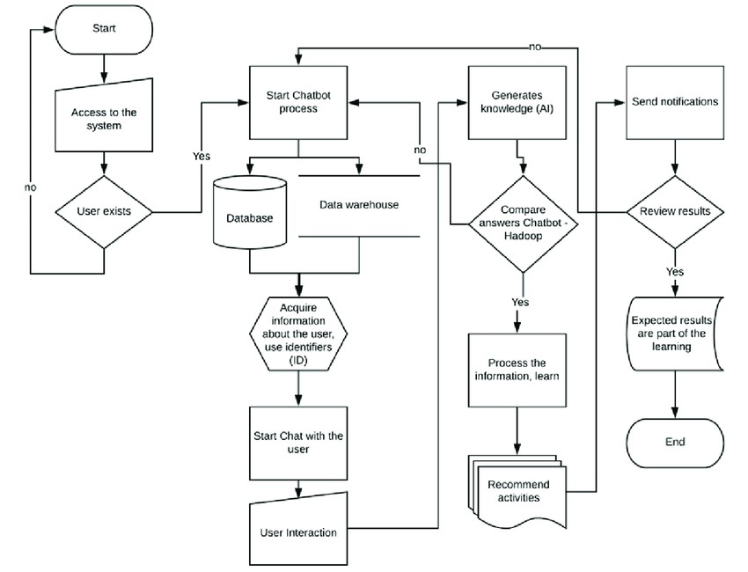

**Figure 5.1**

# 

# Chapter 6

# Implementation

**Physical design:**

The chatbot will be capable of processing user voice input, generating appropriate responses, and storing chat history in a SQLite3 database. The application will consist of several forms, each serving a specific purpose. This document will cover the connections with tables, database operations, and the required functions for each form.

6 **Chatbot Forms**

**6.1. Main Chatbot Form**

The main chatbot form is the primary interface where users can interact with the voice chatbot. It will include a chat history area to display messages exchanged between the user and the chatbot. The form will also have a microphone icon button that users can press to start voice input.,

**Database Connection:**

The main chatbot form will connect to the SQLite3 database to store chat history.

Required Database Operations:

Insert user messages and chatbot responses into the "chat history" table.

The "chat_history" table should include columns for "user_message," "bot_response," and "timestamp."

**Required Functions:**

get_bot_response(user_message): This function will process the user's voice input, generate a response using the chatbot model, and return the response.

insert_chat_data(user_message, bot_response): This function will insert the user message and chatbot response into the "chat_history" table in the database.

**6.2. Admin Login Form**

The admin login form allows authorized users to log in as administrators. It will have fields for entering the username and password.

Database Connection:

The admin login form will connect to the SQLite3 database to verify administrator credentials.

Required Database Operations:

Create an "admin" table to store admin usernames and passwords.

**Required Functions:**

Valida1ate_admin_credentials(username, password): This function will check the entered username and password against the "admin" table in the database and return True if the credentials are valid.

**6.3. Report Form**

The report form is accessible to administrators only. It allows administrators to view and analyze chat history and generate reports.

**Database Connection:**

The report form will connect to the SQLite3 database to retrieve chat history data.

Required Database Operations:

Retrieve chat history data from the "chat_history" table.

**Required Functions**:

get_chat_history(): This function will fetch chat history data from the "chat_history" table and return it to the report form.

Connection with Function Requirements

**Main Chatbot Form:**

Connects to the database to store chat history.

Requires the get_bot_response (user_message) function to generate chatbot responses.

Requires the insert_chat_data(user_message, bot_response) function to store chat history data.

**Admin Login Form:**

Connects to the database to verify admin credentials.

Requires the validate_admin_credentials(username, password) function to validate admin login.

**Report Form:**

Connects to the database to retrieve chat history data.

Requires the get_chat_history() function to fetch chat history data.

# Chapter 7

# Reference of Research Paper

**Reference and Bibliography**

1. Jurafsky, D., & Martin, J. H. (2019). Speech and Language Processing. Pearson.
2. Xu, A., Liu, Z., Guo, Y., Sinha, V., & Akkiraju, R. (2017). A New Chatbot for Customer Service on Social Media. Proceedings of the SIGCHI Conference on Human Factors in Computing Systems.
3. Hirschberg, J., & Manning, C. D. (2015). Advances in Natural Language Processing. Science, 349(6245), 261-266.
4. Young, S., Gašić, M., Thomson, B., & Williams, J. D. (2018). POMDP-based Statistical Spoken Dialogue Systems: A Review. Proceedings of the IEEE, 101(5), 1160-1179.
5. Vinyals, O., & Le, Q. (2015). A Neural Conversational Model. arXiv preprint arXiv:1506.05869.
6. Rasa, A., Singh, S., & Kossmann, J. (2018). Open Domain Conversational Agents: Current Progress and Future Directions. Computer Science Review, 30, 70-88.
7. Gao, J., Galley, M., & Li, L. (2019). Neural Approaches to Conversational AI. Foundations and Trends® in Information Retrieval, 13(2-3), 127-298.
8. Serban, I. V., Lowe, R., Charlin, L., & Pineau, J. (2016). Generative Deep Neural Networks for Dialogue: A Short Review. arXiv preprint arXiv:1611.06216.
9. Chen, X., Xu, L., Liu, X., & Zeng, H. (2017). Improving Conversational AI with Deep Learning. International Conference on Machine Learning and Applications (ICMLA).

1.